Emmanuel Martinez

EGN4060C FALL 2014

Homework Assignment 1

August 27, 2014

“ASIMO” by Honda

Dreams are becoming a reality in Honda’s Research & Development department these days with “ASIMO”. What began as an initial design that can assist humans with everyday tasks is now the world’s most advanced humanoid robot with many 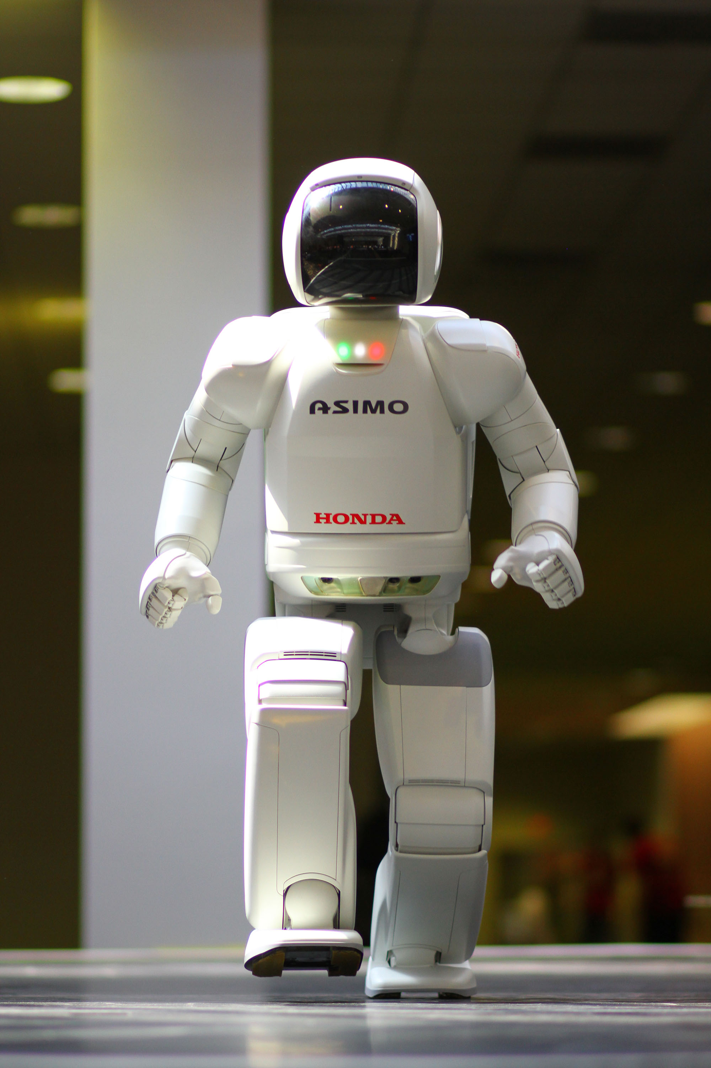complex features and movements that of which replicate humans. After two decades of study, research, and trial and error, Honda engineers and ASIMO are breaking the barriers of what many deemed the impossible. ASIMO’s currently moves with 57 degrees of freedom[2] (each degree is the ability to move right and left or up and down). With the help of powerful computers, sophisticated software, and advanced motion dynamics, ASIMO demonstrates a strong past and bright future for the robotic industry.

Figure 1. ASIMO [1, p. 2]

ASIMO was created specifically with a goal to help make peoples lives easier [3]. It currently can perform several tasks one of which it interacts with one or several humans and converses using A.I. One example of this is the ability to receive several orders of drinks from multiple people all at once. ASIMO then processes this information and retrieves the specific drinks. To successfully achieve this goal it needed to have embedded sensors that replicate a humans 5 senses. These sensors are then programmed for useful technologies such as facial and voice recognition, obstacle and collision avoidance, and balancing during movement. There are also sensors embedded in the fingertips to detect the hardness of an object so it can use a dynamic amount of strength and grips.

With features already included that enable ASIMO to navigate and operate around our world, ASIMO would be an ideal candidate for those humans lacking full mobility. Engineers at Honda much continue asking themselves questions like “what kind of robot can change society?” or “what kind of robot can make life easier for people around the world today and tomorrow?”. The future looks promising for ASIMO and while it has been more than two decades, it still feels like it’s the beginning for major robot technological breakthroughs.

References

[1] ASIMO http://upload.wikimedia.org/wikipedia/commons/3/39/ASIMO_4.28.11.jpg

[2] *ASIMO Specifications*, <http://asimo.honda.com/asimo-specs/>

[3] *HONDA – Meet ASIMO*, <http://corporate.honda.com/innovation/asimo.aspx>